EoF Pool League App Spec

# Purpose

The initial purpose of this project is to allow a platform for the creation and easy maintaining of a sports pool league. Through user creation, retrieval, updating and deleting of data the app will manage various features.

# What it does?

The application will allow users to log in and view the current league their account is subscribed to. In this view, it will show the user the league standings in a tabular format with columns named; Position, Team, Wins, Draws, Losses, Frames won, Frames lost, Points and Frame Difference. Underneath this league will be a fixture list with all upcoming matches for that week. The seasons fixture list will be generated randomly at the beginning of the leagues creation, and will be appropriate to the league admins requirements. (size of league and frequency of playing)

The app will also allow users to select a team from the league view and show a roster of players with appropriate information (The captain of the team will always be displayed at the top of the roster). Such information will be detailed within a table again, with columns named; Name, Age, Frames won, Frames lost. Within the team view, a history of team specific fixtures will be available to the be viewed by users as will current fixture and future fixtures.

# Why does it need to exist?

The reason for the applications need to exist is because the league is managed physically through tedious tasks. These tasks include hand written scores been given to a league chairperson and using the scores to update league standings through an excel sheet.

If the league was digitized it would save the time and effort of the chairperson. Since the league would now exist within the application, the captains of each team would update their scores into the league and the app would autonomously update league standings.

Also, with the league existing within the app, all players and captains could view the standings and other appropriate information in real time for referencing within league meetings instead of rummaging through booklets. In turn, saving time and effort of everyone involved.

# Who will use it?

The importance of this section is to list who the users of the application will be. So far, the only people who will be eligible to use this application will be the Chair of the East of Fife Pool League, Captains of this league and Players of this league.   
  
If successful this application could be opened to any pool league within the UK to allow them to manage their own leagues efficiently.

# High-Level Entities

To fully model the solution, it is key that I state and describe major constructs of the application. The list of these constructs, with descriptions are as follows:

* Data Objects
* The data objects are the main components of how Account, League, Fixtures and other appropriate information is stored within the app, before being made ready to the data access layer.
* These objects will have methods which will function with the application itself. (i.e. Adding a player to a team, updating fixtures, deleting players from a team and viewing league tables.)
* Web service
* This entity will allow the application’s features to be accessed remotely by a user out with the local network.
* The web service entity should establish a connection from the user’s network to the databases local network through a log in screen.
* Controller Object
* This structure will be a main component for how the application and GUI interacts with the user.
* The controller will bridge the methods from the data objects and/or application with the GUI. So, whenever a button is clicked on the GUI the controller can send a message to the application and call the appropriate method from the application itself or from the data objects.
* Data access layer
* The data access layer will be the part of the application which allows the objects to communicate with the database.
* Simply put, it will translate user interactions from an object (i.e. Captain) and allow them to create, retrieve, update or delete information within the database. (i.e. Add Player to Team)
* This will in-turn increase to autonomy of the app.

These interactions are shown, diagrammatically, on the next page.

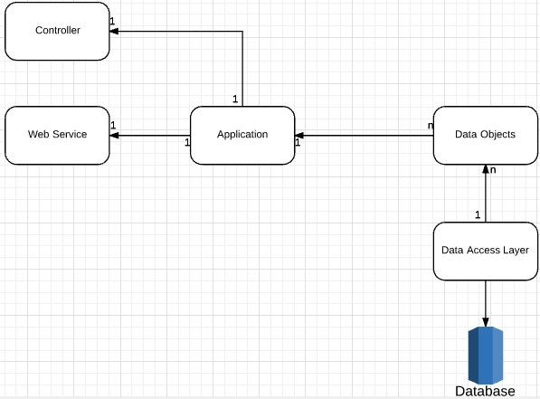

Such features will include:

1. Account creation with the providing of a valid e-mail address and valid password (numbers and letters)
   1. There will be different account levels within the app. For example; League admin, Captain and Player.
      1. League admin will control the setting up and maintenance of the league.
      2. Captain will control the setting up, maintenance and inserting the score of a match into the app.
      3. Player will control maintaining their own data.
2. League creation with a set number of teams within the league, but the ability to edit size of the league will be available to league admin only.
3. Team creation